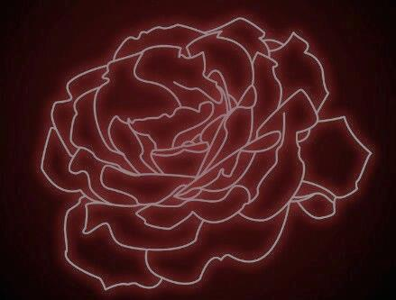

Omaha Homeschool Homecoming 2017
La Vie En Rouge
September 29th
7-11:30pm
$25, due by September 8th
The Hills Event Venue
7040 N 102nd Circle, Omaha, NE 68122

See the website for more details:
https://hshomecoming.wixsite.com/2017
Or Email Us at:
hshomecoming@gmail.com

